**Experiment 3.3**

**Aim:** To write python program to Implement inheritance and polymorphism, Method overriding and overloading

**Solution:**

Inheritance and Polymorphism:

class Vehicle:

def __init__(self, name, color):

self.__name = name

self.__color = color

def getColor(self):

return self.__color

def setColor(self, color):

self.__color = color

def getName(self):

return self.__name

class Car(Vehicle):

def __init__(self, name, color, model):

super().__init__(name, color)

self.__model = model

def setColor(self):

print ("Its Overriding")

def getDescription(self):

return self.getName() + self.__model + " in " +

self.getColor() + " color"

class Bike(Vehicle):

def __init__(self, name, color, model):

self.__name = name

self.__color = color

self.__model = model

def getColor(self):

print ("Its Overloading")

return self.__color

def getDescription(self):

return self.getName() + self.__model + " in "

+ self.getColor() + " color"

c = Car("Ford Mustang", "red", "GT350")

print(c.setColor())

print(c.getDescription())

print(c.getName())

b = Bike("Avenger", "Blue", "GTX220")

print(b.getColor())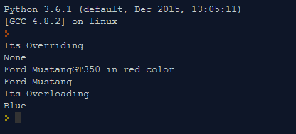

Operator Overloading

import math

class Circle:

def __init__(self, radius):

self.__radius = radius

def setRadius(self, radius):

self.__radius = radius

def getRadius(self):

return self.__radius

def area(self):

return math.pi * self.__radius ** 2

def __add__(self, another_circle):

return Circle( self.__radius + another_circle.__radius )

def __gt__(self, another_circle):

return self.__radius > another_circle.__radius

def __lt__(self, another_circle):

return self.__radius < another_circle.__radius

def __str__(self):

return "Circle with radius " + str(self.__radius)

c1 = Circle(4)

print(c1.getRadius())

c2 = Circle(5)

print(c2.getRadius())

c3 = c1 + c2

print(c3.getRadius())

print( c3 > c2)

print( c1 < c2)

print(c3)

